Operating procedures for engagement with agents via an authority to act

27 February 2026
These procedures provide internal guidance for how Redress agencies should operate when a survivor wants to have someone act on their behalf (the agent) in relation to their claim for redress. How this occurs will differ case by case, but a survivor must fill out an Authority to act form for an agent to act on their behalf.
This document does not cover situations where the survivor is represented by a lawyer who holds a current practising certificate issued by the NZ Law Society. This is because a lawyer does not need to complete an authority to act to represent a survivor.
Who is an agent?
Agents are people who can support, advocate for, and represent the survivor. They can have a personal relationship or a professional relationship with the survivor. Agents can include (but are not limited to) whānau, caregivers, Iwi, or advocacy groups.
What do agents do?
Agents may be involved in various parts of the process. Some agents may initiate contact and then have the survivor continue the process on their own. The agent may then shift into a support person role. Other agents may act on behalf of the survivor throughout the entire process.
Regardless of who is the primary contact, the needs of the survivor remain the central focus of assessments, recommendations, and outcomes.
Can an agent complete the Consent and Declaration form?
Because of the nature of the Consent and Declaration form Survivors will still need to complete this form themselves (not including survivors with legal representation from a lawyer, refer to the Consent and Declaration form for legal representatives).
What if there are concerns about the behaviour of the agent?
There are some risks inherent when engaging with agents. These include the existence of a conflict of interest, or where the survivor’s views are different to that of the agent and are not reflected in the process or outcome. There is also a risk for the redress outcome to be abused.
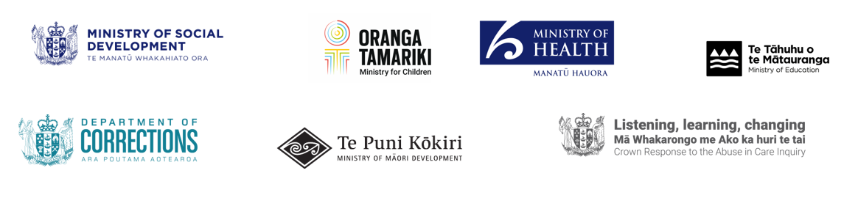
If there are any concerns about the behaviour of an agent, this should be escalated to a manager or team leader. The agency can then work through the best approach to managing the concerns to ensure an outcome that is in the best interests of the survivor.
Before taking any action, redress agencies should consider how the well-being of the survivor could be impacted.
Are there any record keeping requirements in relation to agents?
Anytime a survivor has completed an Authority to act form, it and any associated documentation need to be stored alongside documents associated with their claim. Anyone working through their claim will need to know the details of the authority to act so that they are working/communicating with the correct person.
It is important to remember that this documentation will also need to be stored securely and in accordance with the Redress agencies’ privacy, information management, and information security policies, as well as any other relevant policies.

