Interim process for managing presumption against serious violent and/or sexual offenders

Standard Operating Procedure for Redress Agency Staff

Introduction
On 9 May 2025, the Government announced changes to existing and new redress processes currently handled by the Ministry of Social Development, Oranga Tamariki, Ministry of Education, Ministry of Health, Department of Corrections and Te Puni Kōkiri (the redress agencies).
One of the changes applies to new claims from survivors with convictions for serious violent or sexual offences and who have been sentenced to five years or more in prison. This is to ensure the redress system is not brought into disrepute.
Survivors that fit within this category would not be able to access the financial part of redress.
An independent decision-maker will be appointed to review any appeals from survivors that meet the criteria and were unable to get a financial payment, following the enactment of new legislation in June.
Survivors who are terminally ill will be prioritised. Until legislation is in place, an interim process is in place for terminally ill survivors.

Purpose of the procedure
The following guidance provides a step-by-step guide for redress agency staff on how to manage presumption against serious violent and/or sexual offenders. This guidance has been developed in partnership with redress agencies to support consistent implementation.
This procedure will be updated once legislation is enacted and the independent decision-maker has been appointed (anticipated September 2026).
Applies to
This procedure applies to all redress agency staff responsible for managing new claims made since 9 May 2025 and is to be used to implement presumption against serious violent and/or sexual offenders.
Note: This procedure does not apply to claims made before 9 May 2025 or, in the rare circumstance, where a settlement offer is reopened for a claim made prior to 9 May 2025. In this situation, the claim would not fall within the definition of a new claim received after the 9 May 2025 and would not require consent and declaration forms to be completed.
Whilst this process has not been designed to support the work of the Specialised Assessment Unit, it is encouraged staff in the Unit are across this guidance for completeness.
Scope
All new claims from 9 May 2025 are in scope for this procedure as this is when Government agreed to introduce this new process.
This process will result in survivors who have been convicted of serious violent and sexual offences (as per Schedule 1AB of the Sentencing Act 2002) and have been sentenced to five or more years in prison not receiving financial redress payment as part of their settlement.
The Lead Coordination Minister is authorised to exempt a claimant from the presumption against redress where they have a terminal illness that is likely to end their life before the legislation is implemented.
Survivors under 18 years of age cannot receive financial redress until they turn 18. Like all other applicants they will need to fill out the declaration form and have the form processed by the Specialised Assessment Unit before they receive financial redress after they turn 18.

Procedure summary
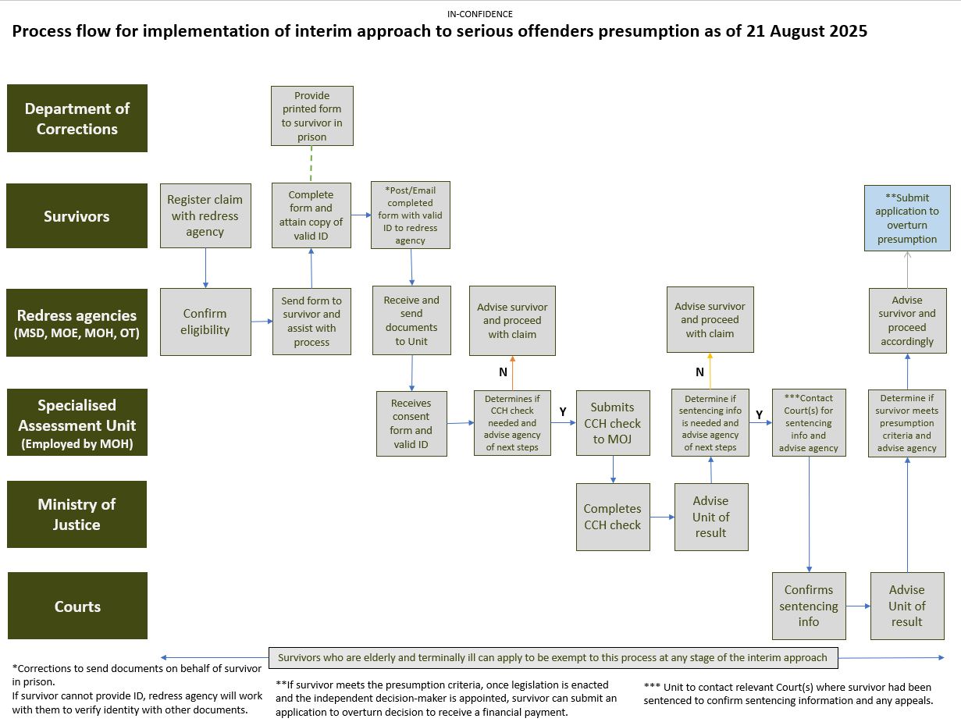
Redress Agency Procedure
- Claim registered
- Survivor registers their claim with a redress agency.
- Confirm the survivor’s eligibility for a redress claim.
- Note: Continue to use your agency’s existing processes to register and record a claim in your existing systems.
- Advise survivor of new process
    - Advise the survivor of the new process for new claims after 9 May 2025 that requires a criminal conviction history check before their financial redress claim can be assessed.
      - If required, use the script, talking points and FAQs to support with this conversation.
      - Only survivors seeking financial redress need to follow this process. If the survivor is not seeking financial redress, this process does not need to be followed.
      - If the survivor is under 18 but wishes to pursue financial redress once they turn 18 then they will be subject to this process at that time (see Additional Information: Approach for completing checks for survivors who are Under 18 for more information).
      - If the survivor has a terminal illness that is likely to end their life before the legislation is implemented the Lead Coordination Minister can exempt them from the presumption against redress.

    - If the survivor advises that they are terminally ill
      - Confirm health status of survivor.
      - Survivor to provide details regarding their terminal illness with the agency
      - The information must include confirmation of a terminal diagnosis and prognosis from a medical professional.
      - Agency to prepare briefing to Lead Coordination Minister outlining the status of the survivor and requesting an exemption from the process.
      - If exempted, survivor can continue with financial redress.
      - If not exempted standard process should continue to be used.
- Support survivor to complete forms
    - Provide survivor with the consent and declaration form (via email or post) and ask them if they have filled out this form previously.
      - If they have filled out the declaration form previously, they only need to complete the personal details section (for matching purposes). The form should then be submitted to the Specialised Assessment Unit (the Unit) for checking against the Unit’s records.
      - If the survivor has been convicted of a serious offence (as per Schedule 1AB of the Sentencing Act 2002) and has been sentenced to five or more years in prison since completing the previous form, they are responsible for informing any redress agencies they have open redress claims with.

    - Work with the survivor if they need assistance with completing the consent and declaration form.
    - Reiterate to the survivor to fill out all details as much as possible and not to worry if they cannot fill out all details such as providing all their past addresses.
    - Make sure the survivor is aware that if they have a change to their criminal conviction history after submitting the form, they must notify the redress agency immediately. (See What to do when there are concerns about declarations in Additional Information for more information on this).
    - Advise the survivor that a copy of a form of valid ID is required to verify their identity. Valid ID includes:
      - New Zealand or Overseas Passport (please include the first page with photo and details as well as the page with signature),
      - New Zealand driver’s license (please provide a copy of both sides),
      - New Zealand firearms license.
- If they do not have a valid form of ID, they can fill out a statutory declaration or proof of identity form.
    - The declaration must be signed by an authorised person, such as a Justice of the Peace, Court Registrar or Solicitor.
    - If the applicant provided you with a proof of identity form where someone else is vouching for their identity, the person who vouched for the applicant’s identity:
      - must not be their relative
      - must not be living at the same address
      - must be 18 years of age or over, and
      - must have known the applicant for more than 12 months.

    - If the survivor cannot provide a valid form of ID, redress agencies should contact the Crown Response Office for advice on how to progress the application.
- Receive completed form and survivors’ identity and send to the Specialised Assessment Unit

- Redress agency receives and collates the completed consent and declaration form and valid form of ID.
    - Redress agency then emails all documentation to the Specialised Assessment Units email address.
    - Due to the nature of information being sent between redress agencies and the Specialised Assessment Unit all correspondence should be via email. Information coming to the Specialised Assessment Unit should only come to (EMAIL ADDRESS) unless otherwise specified.
    - Every email and document should be marked as [SENSITIVE] and must be internally tracked, including tracking of what documents have been sent.
    - Redress agency to provide survivor’s documentation even if the survivor declares ‘no’ they do not have an applicable criminal conviction.
- Specialised Assessment Unit undertakes check
    - The Special Assessment Unit progresses all necessary criminal conviction history checks with the Ministry of Justice and sentencing checks with the Courts. The Specialised Assessment Unit will then inform the redress agency via email of the outcome of the checks. (see Appendix 1 for more information)
- Outcome of check advised by Specialised Assessment Unit
    - Once the outcome of the Specialised Assessment Unit check has been received the Redress agency informs the survivor of outcome and notes on their system that this has been done. Agency can proceed with providing financial redress (if applicable).
    - If the survivor meets the presumption, the redress agency can provide other redress offerings.
    - The redress agency can advise the survivor that they will be able to apply to have the presumption overturned once legislation is enacted and the independent decision-maker has been appointed. The process to do this will not be available until the legislation is enacted.
    - Each Redress agency will have processes in place for tracking any survivors who have been identified as being prevented for receiving financial redress so that further communications can be provided to these individuals about how to apply to have the presumption overturned once the independent decision maker is in place.
    - Redress agencies are responsible for confirming that a survivor who has registered their claims after 9 May 2025 have completed the checking process and confirmation has been received from the Specialised Assessment Unit that the individual is able to receive financial redress prior to a settlement offer being made.
Additional Information
Approach for completing checks for survivors who are Under 18
- Survivors under 18 years of age cannot receive financial redress until after they turn 18. To receive financial redress (after they turn 18) they will need to fill out the declaration form and have the form processed by the Specialised Assessment Unit.

- There are no restrictions for those under 18 to fill out the declaration form but the person signing it must be capable of understanding the nature and significance of the declaration and be able to truthfully affirm the contents of the declaration.

- Because of this it is advisable for redress agencies to wait until survivors are 18 before getting them to fill out the declaration form if they wish to proceed with financial redress.
What to do when there are concerns about declarations
- If a redress agency is concerned about a survivor's declaration at the time of submission they should discuss this with the survivor. This will help to minimise any chances that survivors fill out the form incorrectly.

- If a survivor has disclosed information to the redress agency that is counter to the information provided in their declaration and consent form, the redress agency must inform the Specialised Assessment Unit. The Specialised Assessment Unit will then decide if the survivor's declaration should be checked through the criminal conviction history checking process.

- Survivors must inform the redress agency if there is a change to their criminal conviction history. Wrongfully disclosing information when completing the form is currently a criminal offence as per section 111 and 241 of the Crimes Act 1961, with a maximum penalty of three years imprisonment.

- Redress agencies need to ensure that any survivor applying for financial redress understands what this means to minimise the chance that they fail to inform the redress agency of a change.

- If a redress agency staff member believes that a survivor's declaration has changed since initial declaration, this should be discussed with the survivor. If this does not resolve the issue the redress agency should inform the Specialised Assessment Unit via email. The redress agency must include a brief rationale for their suspicion and what the survivor has stated along with as much information as possible (including the survivors personal details) to help the Specialised Assessment Unit identify the survivor’s records to investigate the matter.
Overseas convictions
- Currently, survivors do not need to declare convictions from overseas jurisdictions.
Important Note: this is an interim approach which is subject to change.

Key documentation
Title | Description
High level process flow | High level end-to-end process for the implementation of the interim approach for serious offenders presumption
Detailed Process Flow | Step-by-step guide for redress agency staff on managing the interim approach for serious offenders
Talking points for redress agencies to survivors | Key messages for redress agencies when discussing serious offenders presumption with survivors
FAQs | Responses to support dress agency staff with answering questions on serious offenders presumption. Also includes an email template for survivors with claims currently on hold due to the presumption process

Appendix 1: Assessment Unit Procedure
Specialised Assessment Unit receives an application from a redress agency along with
declaration form and survivors ID.

- Survivor declares ‘yes’ or ‘unsure’ to applicable criminal conviction
    - Criminal Conviction History Check to be progressed.
    - Specialised Assessment Unit to submit request for criminal conviction history check to Ministry of Justice.
    - Once check is complete Specialised Assessment Unit will inform redress agency of outcome.
    - If applicable conviction is identified Specialised Assessment Unit to submit request for sentencing check to Ministry of Justice.
    - Once check is complete Specialised Assessment Unit will inform redress agency of outcome.
- Survivor declares ‘no’ to applicable criminal conviction
    - Specialised Assessment Unit will put application through randomised checking process to determine if it is to progress through criminal conviction history check.
    - If application is not selected to go through criminal conviction history check, Specialised Assessment Unit will inform the agency of outcome.
    - Once check is complete the Specialised Assessment Unit will inform the redress agency whether they can proceed with providing financial redress (if applicable) or if sentencing information is needed.
    - Specialised Assessment Unit to submit requests for sentencing information to Courts via the Ministry of Justice.
    - Once sentencing check is complete the Specialised Assessment Unit will inform the redress agency of outcome.

